Dayempur Farm
Center for Sustainable Living
Volunteer Application

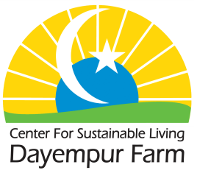

Full Name: Date:

Address:

Phone Number: Email:

Highest level of education? High school College Trade school
Current or previous areas of study?

Preferred dates of visit:

Are your preferred dates flexible? Yes No

Do you have any previous experience, knowledge, or skills that may contribute to Farm work?

Why are you interested in volunteering at Dayempur Farm, Center for Sustainable Living?

Have you ever been convicted of a felony? Yes No

If Yes, please explain:

Do you have any physical limitations/considerations? Yes No

If Yes, please explain:

Do you have any dietary restrictions? Yes No

If Yes, please explain:

Are you interested in onsite housing? (peaceful, rustic cabins available) Yes No

Are you open to staying in a tent? (tent/cot/bedding may be provided) Yes No

Do you have local means of transportation? (15 miles South of Carbondale, IL) Yes No

Do you have concerns with the butchering of farm animals? (not required) Yes No

Please list two references:
(Volunteer and work exchange references welcome. Please list at least one professional reference)

Full Name: Relationship:

Company: Phone:

Address:

Full Name: Relationship:

Company: Phone:

Address:

Emergency Contact:

Full Name: Relationship:

Phone: Address:

Disclaimer and Signature

I certify that my answers are true and complete to the best of my ability. If this application leads to acceptance in the Dayempur Farm volunteer program, I understand that false or misleading information in my application may result in my release.

Signature: Date:

Submit application to: Dayempur Farm Manager
35 Nubbin Ridge Rd. Anna, Illinois 62906
or via e-mail: dayempurfarm@gmail.com

